HACKATHON 3 – DAY 2
PROJECT: MARKETPLACE TECHNICAL FOUNDATION
AUTHOR: ZARA ASIM
ROLL NUMBER: 470331
This document outlines the user journey flow for an e-commerce marketplace. In simple terms, it explains how a user would interact with an online store from start to finish.
Keep steps in the user journey:
- Homepage:
- The user starts on the main page of the store.
- The page shows popular product categories, trending items and search bar.
- Product Detail page:
- The user clicks on a product to see more information.
- This page displays the product description, price description, price availability and customer reviews.
- Add to cart:
- The user adds the product to their shopping cart.
- The cart updates automatically with the selected quantity and total cost.
- Checkout:
- The user proceeds to checkout to complete their purchase.
ORDER PROCESS”
- Payments:
- The user will enter all payments details
- Secured payment methods will processes the transaction.
- ORDER CONFIRMATION:
- The user will see order details on the screen and get an email confirmation. The system also updates the order status.
- Shipment tracking:
- The user can track the orders delivery progress in the “order history” section.
- Delivery:
- The users product is delivered at their doorstep

FRONTEND REQUIREMENTS:
- The user will get a notification to leave a review.
- The website has all the essential pages: Home, Product Listing, Product details, Cart, Checkout and order confirmation.

FLOWCHART OF FRONTEND
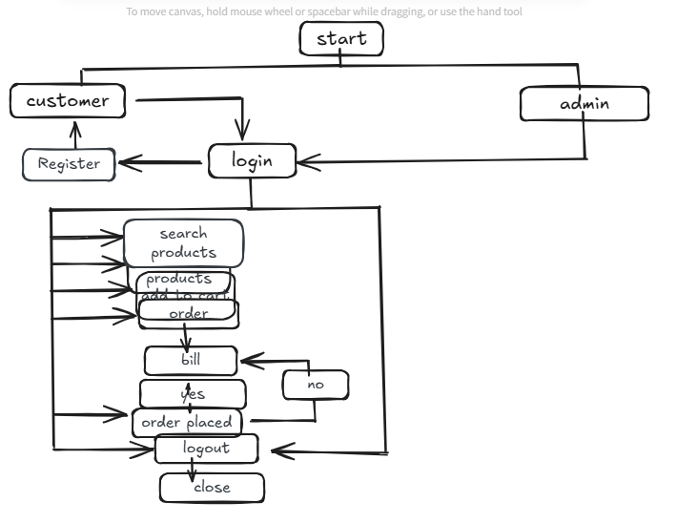

SYSTEM ARCHITECTURE
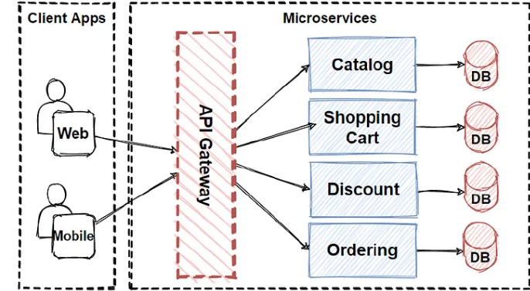

FRONT-END NEXT JS:
When architecting a large-scale front-end system, performance and SEO are non-negotiable. Next.js is a React-based framework that addresses both, offering server-side rendering (SSR), static site generation (SSG), and a hybrid approach that combines the best of both worlds.
Key Benefits of Next.js:
1. Server-Side Rendering (SSR): Pre-render your pages on the server for faster load times and improved SEO. This is crucial for content-heavy websites and dynamic apps that need to be SEO-friendly.
2. Static Site Generation (SSG): Pre-build your static pages at build time, reducing the load on your server and enhancing performance for pages that don’t change often, like blogs or product listings.
3. API Routes: Next.js allows you to build API endpoints within the same codebase, making it easy to integrate server-side functionality without spinning up a separate backend server.
4. File-Based Routing: No need for third-party routing libraries like React Router. Next.js uses a file-based routing system, where your directory structure defines your app’s routes — making it intuitive and easy to manage.
5. Performance Optimizations: Features like automatic image optimization, code-splitting, and lazy loading ensure that your app performs smoothly, even under heavy load.

